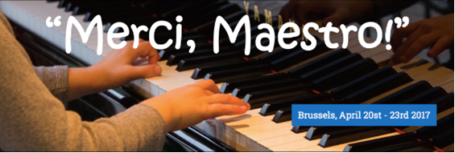
The participants of the second edition will have the opportunity to perform on a Steinway & Sons piano in front of a large audience and such influential personalities in the world of music as: François Thiry, Olivier Roberti, Ayrton Desimpelaere, Nataliya Chepurenko, Lubov Aroutiounian, Alexandre Eggericx, Milana Chernyavska, Armen-Levon Manaseryan, Dominique Cornil, Ksenia Kogan.
The First Prize winners will receive a unique opportunity to perform at the Gala Concert of the next edition of our competition in Brussels with a symphony orchestra. Some of the winners will be awarded with scholarships to take part in master classes with famous pianists.
There are several categories:
- CAT A: for candidates younger than 10 years old at the time of the Competition;
- CAT B: for candidates from 11 to 14 years old at the time of the Competition;
- CAT C: for candidates from 15 to 19 years old for the time of the Competition.
If needed, foreign participants may use this letter as a support for entrance visa application. However, the Competition organizer will not be responsible for obtaining visas and the costs related to this application.
The organisers will provide all possible information and assistance for accommodation of participants and accompanying persons in hotels with favourable rates or in carefully selected host families.
The application deadlines are before the 1st February 2017 for non-European Union citizens and before the 1st March 2017 for the citizens of the European Union.
Additional information (for details please check the Info section on our web site):
- Availability of the transfers upon arrival: airport – hotel (or secretary office of the competition)- airport;
- Discounts for rooms in the hotel "Ramada" during the period of competition;
- Possibility to stay in host families (free);
- Excursions in Brussels (for all participants that have not passed the final -free as a consolation prize);
- Excursions to Bruges (Belgium), Amsterdam, Paris, in English or Russian languages.
For further information, please visit the competition website: http://www.mercimaestro.be/en/ or contact us by email: info@mercimaestro.be or by phone: +32 (0)496 48 87 80.
Here you can find a summary movie from the first edition of "Merci, Maestro!" competition in 2016: https://youtu.be/gsyncui-bUU

